**SWE1008 – WEB TECHNOLOGIES**

**DIGITAL ASSIGNMENT-1**



**FACULTY:** PROFBRINDHA.K

**Submitted by:**  P HARSHA CHANDAN REDDY

Registration Number : 16MIS0182

***Online Health Shopping Portal:***

**This site helps the clients in curing its sickness by giving the rundown of foods grown from the ground that the client ought to devour with a specific end goal to dispose of its malady. The primary reason for this site is to help the client to effectively scan for herbs and organic products that will be useful for the health of the client relying upon any health issue or malady that he/she is experiencing. This framework encourages the client to diminish its seeking time, all things considered, by enabling the client to enter its health issue and pursuit appropriately. The administrator can add products of the soil to the framework and its data. This framework additionally enables the client to see the chose organic product or the herb's portrayal which depicts how the natural product or the herb will enhance the client's health. This framework likewise enables the client to put arrange which will add the things to the client's truck and make instalment for the same. In this manner, this framework gets nourishment items most appropriate for client health all things considered. Framework can prescribe some item to the client.**

**1ST PAGE IN THE ONLINE HELATH SHOPPING PORTAL**

<html>

<head>

<title>ONLINE HEALTH SHOPPING PORTAL</title>

</head>

<frameset rows="40%,*">

<frame src="1m.html" noresize="noresize">

<frame src="2pagem.html"noresize="noresize">

</frameset>

</html>

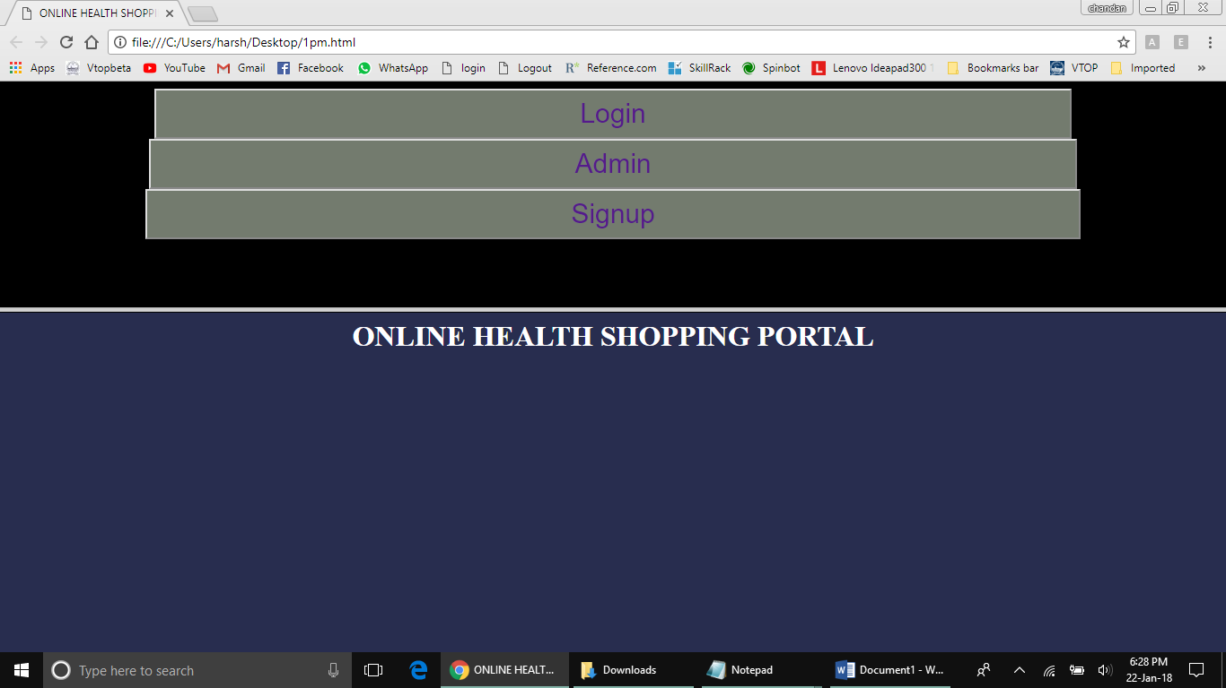

**1st main frame:**

<html>

<head>

<style>

.button

{

background-color:#737B6E;

color: white;

text-decoration:none;text-align: center;

font-size:30px;

cursor:pointer;

}

</style>

</head>

<body bgcolor="black" align="center">

<a href="userlogin.html.html" target="_blank" style='text-decoration:none;'><button type="button" class="button" style="padding: 9px 35%;" name="login">Login</a></button><br>

<a href="adminloginm.html" target="_blank" style='text-decoration:none;'><button type="button" class="button" style="padding: 9px 35%;" name="admin">Admin</a></button><br>

<a href="signup.html" target="_blank" style='text-decoration:none;'>

<button type="button" class="button" style="padding:9px 35%;" name="signup">Signup</a></button><br>

</body>

</html>

**2nd frame:**

<html>

<body bgcolor=#282D4F color="white" size=400px background-repeat:no-repeat;background-size:1100px 700px' align="center">

<font color="white">

<p color="white"><h1>ONLINE HEALTH SHOPPING PORTAL</h1></p>

</font>

</body>

</html>

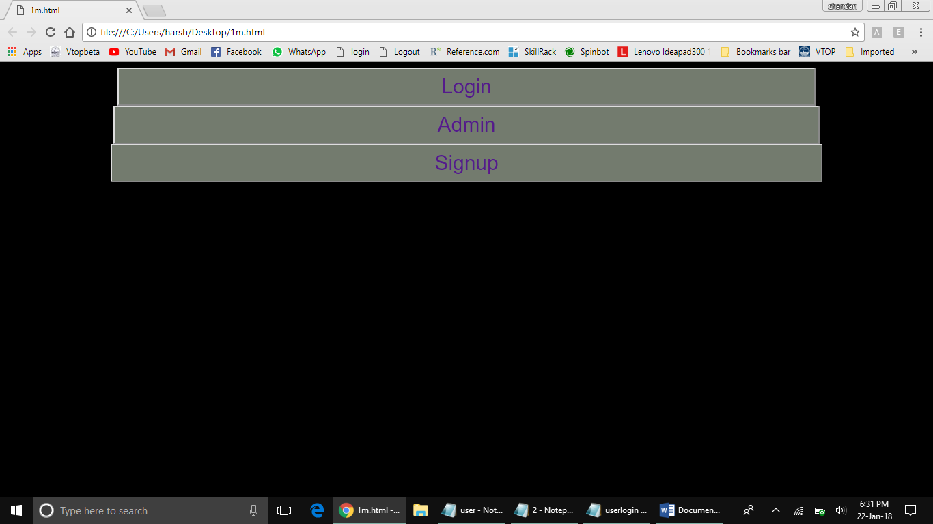

**Admin login page:**

<html>

<head>

</head>

<body bgcolor="#737B6E">

<center>

<form>

<img src="admin.jpg" width=202 height=228 align="center"></img>

<br>

<br>

<br>

<b>

ADMIN ID &nbsp&nbsp&nbsp&nbsp<input type=text><br>

<br>

PASSWORD &nbsp<input type=password><br>

<br>

</b>

<input type=button value=submit>

&nbsp&nbsp&nbsp

<input type=button value=reset>

</center>

</body>

</form>

</html>

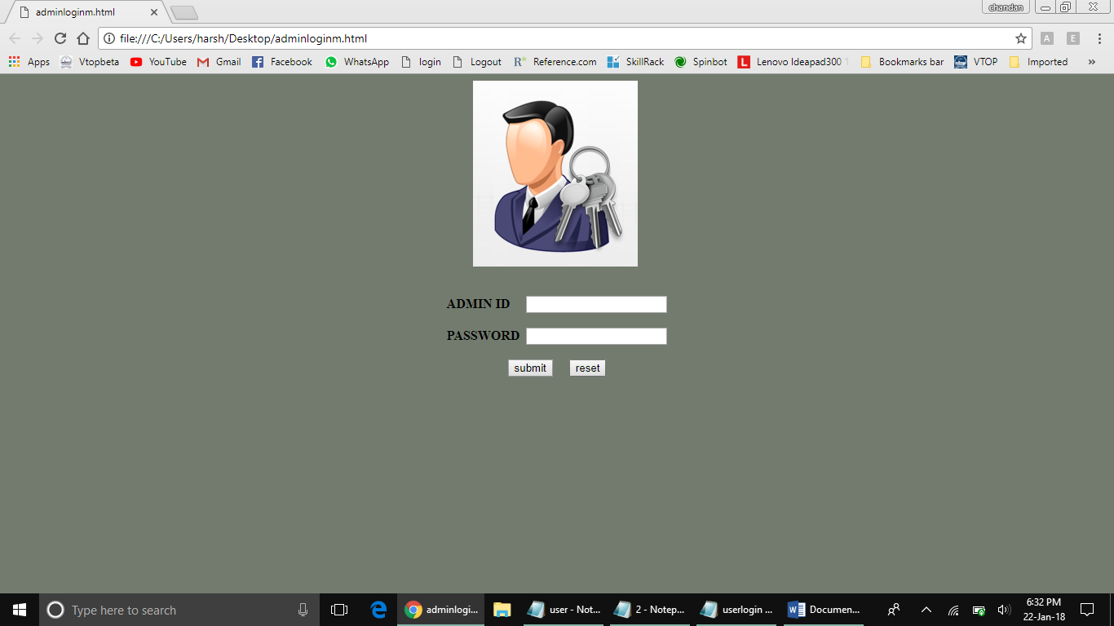

**User login :**

<html>

<head>

</head>

<body bgcolor="#737B6E">

<center>

<form>

<img src="user.png" width=240 height=240 align="center"></img>

<br><b>

<br>

<br>

USER ID &nbsp&nbsp&nbsp&nbsp<input type=text><br>

<br>

PASSWORD &nbsp<input type=password><br>

<br>

</b>

<input type=button value=submit>

&nbsp&nbsp&nbsp

<input type=button value=reset>

</center>

</body>

</form>

</html>

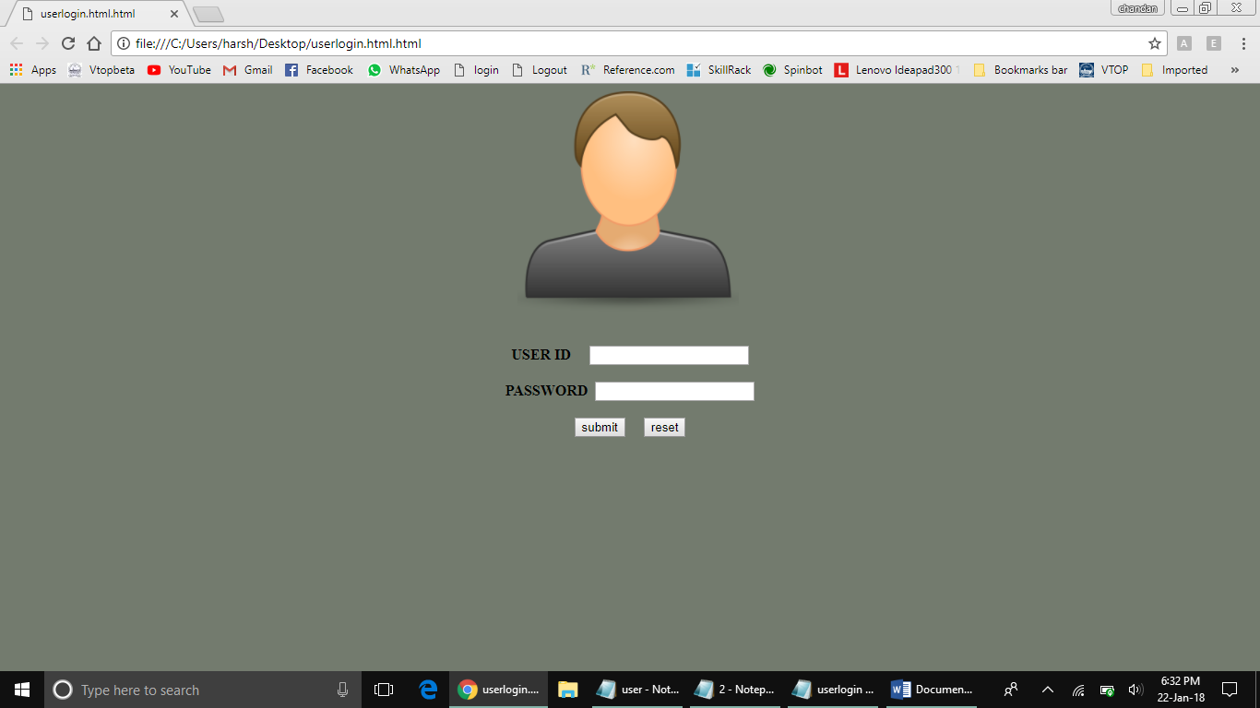

***1 st Frame :***

<html>

<head>

<style>

.button

{

background-color:#2F4F4F;

border:none;

color:white;

padding:23px 110px;

cursor:pointer;

}

</style>

</head>

<body style="background-color:black"><br><br>

<center>

<button type="button" class="button" name="add" style="font-size:23px"><b><i>Logout</b></i></button><br><br>

<button type="button" class="button" name="add" style="font-size:23px"><b><i>Delete</b></i></button><br><br>

<button type="button" class="button" name="add" style="font-size:23px"><b><i>Add</b></i></button><br><br>

<button type="button" class="button" name="add" style="font-size:23px"><b><i>Veiw</b></i></button><br><br>

</center>

</body>

</html>

